Current Market View – December 2025

Investment Markets – Global Markets
Global markets continued their positive trend, rising for most developed regions in December 2025, with Europe and the US outpacing Asia and Australia. Investors continue to discount the impact of inflation and interest rates on asset prices and continue to add to their "risk-on" positions. Equity investors welcomed the US interest rate cut in the last week of October amid signs of a slowing labour market and continued pressure on consumer prices, marking the second rate cut in 2025. This led to the resumption of the "buy the dip" mentality that had been prevalent in recent times.

Whilst the Federal Reserve Bank (the Fed) remains focused on the inflationary impact of the tariffs, the economy is performing well, with limited inflationary impact from the introduction of US tariffs to date, and the Fed cut interest rates in December.
Global Share Markets
In December, the Fed cut interest rates by 0.25% to 3.75%, following a 0.25% cut at the October FOMC meeting. The next Federal Reserve meeting is due to start on the 27th / 28th of January 2026. The Global Markets were stronger in December 2025, with the UK and Europe outpacing Asia and the United States.
December turned out to be a quieter month, albeit with no "Santa Claus" end-of-year rally, a muted end to what had been a stressful and volatile year for investors. 2025 delivered almost everything from sharp drawdowns on macroeconomic shifts to rampaging bull markets for risk assets, and then a December sell-off on the prospect of interest rate rises.
Data Source: AFM as of December 31 2025.
Global Bond Markets
Bond markets remain unconvinced by the tariff reprieve, believing that the outcome will ultimately lead to further inflation. Following the interest rate cut in December, the market is not pricing in any further cuts until the new Federal Reserve chair is announced and settled into the role.
Interest rate markets in the US eased over December 2025, with the 10-year Government bonds increasing to 4.169%. UK 10-year Gilts were trading at 4.571% on December 31 2025.
Domestic Bond Markets
For Australia, the latest inflation prints for (year-on-year) December 2025 increased to 3.4%, which was a slight decrease from 3.8% in December 2025. The RBA board meeting held on 8th/December 9 2025, saw the target cash rate held steady at 3.60%, a continuation from the December meeting. The next RBA Monetary Policy meeting is due on the 2nd/3rd February 2026.
Investment Climate
US equities ended December 2025 on a positive note, capping off a very solid year, lifted by a third consecutive Federal Reserve rate cut and growing confidence that the economy would remain resilient into 2026. Large-cap benchmarks such as the S&P 500 posted moderate monthly gains, supported by easing financial conditions, stabilising inflation data, and renewed interest in cyclical and value stocks after an earlier period dominated by mega-cap growth names. Small caps also participated, though more modestly, as investors rotated toward areas expected to benefit from lower rates and improving credit conditions. Overall, December capped a year defined by volatility early on but a strong recovery in the second half, leaving US equities well-positioned heading into the new year.

Medium-term investors are encouraged by the anticipated gradual easing of interest rates; however, the unsettled nature of the share and bond markets clouds the short-term direction. Soft-landing expectations and economic recovery are still supported by the data, despite recent volatility.
The medium-term view remains positive for returns, as US Fed Chair Jerome Powell appears to have shifted his stance toward further US interest rate easing in 2026. At the December 2025 Meeting, the Fed eased interest rates by 0.25% to 3.75%, with the market anticipating another 0.25% cut later in 2026.
Long-term investors are optimistic about a recovery period ahead. Global central banks continue to indicate a resolve to get inflation under control; however, economic data is showing signs of stabilisation despite elevated inflation, and every indication is that future monetary policy easing is possible in 2025.
The following commentary is based on month-end closing prices as of December 31 2025:
Global share markets were stronger over December, with Europe and the United Kingdom outperforming the US and Australian markets, as returns recovered despite the ongoing tariff situation and subsequent bouts of volatility following each tariff announcement. The AUD/USD strengthened from 0.6550 to 0.6673 (+1.88%).
The US Fed eased monetary policy to the target range for the federal funds rate of 3.50%-3.75% when it met on the 9th/10th December 2025. Investors are gaining more confidence that the economy is headed for a soft landing despite the intermittent bouts of volatility. The next Fed meeting is on the 25th/26th January 2026.
The underlying short-term theme is "risk-on" for shares.
The situation in the Russia/Ukraine conflict remains unchanged; however, the latest conflict between Israel and Gaza (Hamas) has cooled.

Investor Focus
For Australia, investors focused on the following issues:
- Cost of living expenses and the impact on consumer spending.
- Commodity prices (post-China policy changes) and the impact on company profits.
- The level of interest rates and the delicate position of the RBA, given the global volatility in markets.
- US tariffs and the impact on Australia's exports (if any).
- Inflation (year-over-year) increased to 3.8% in December, with the next quarterly CPI being released on January 28, 2026.
- Government spending and the rising debt level.

Currency
Currency forecasters see the AUD/USD range between:
0.65 and 0.75 cents in the medium term and most likely to trade within the:
0.5500 to 0.7500 range in the longer term.

The Australian Dollar closed slightly stronger, AUD/USD 0.6673 at the end of December 2025, up slightly from 0.6550. This was following the Fed cutting rates during the month and the RBA continuing to keep Australian rates on hold.

Australian Economy
Australia's latest GDP data for the third quarter of 2025 revealed an annual growth rate of 2.1%, which was up from 1.8% in the second quarter of 2025. Unemployment fell to 4.3% in October 2025. The year-over-year (Y-O-Y) inflation rate increased to 3.8% in October 2025, up from 3.4% in September 2025, which is now outside the Reserve Bank's targeted 2% to 3% inflation range.
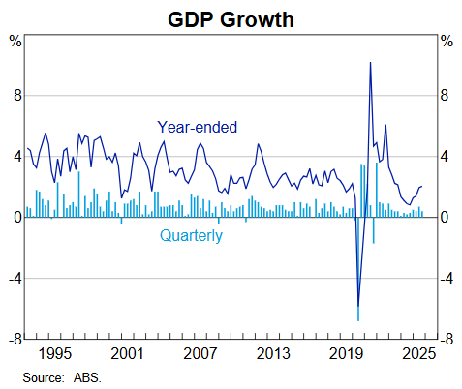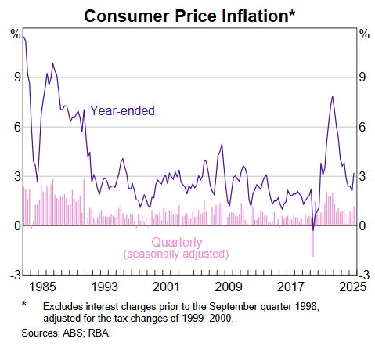

Current Market View – Domestic View
The overall investment view for shares is "risk-on" over the short term, "cautiously optimistic" over the medium term, and "long run" as interest rates are expected to continue trending down, depending on the implementation of tariffs and future anticipated easing of Monetary Policy by the RBA.
The market is expecting no interest rate cuts with maybe an interest rate hike on the 2nd/3rd of February 2026, due to a "hotter" inflation print in December that showed inflation is now outside the RBA's target range of 2-3%.

Global View
The global share market remains optimistic with ongoing support from the Fed, which is likely to cut interest rates once more in 2026. Inflation remains subdued as tariffs haven't impacted the economy fully. GDP remains strong in the US as AI infrastructure investment continues to boost spending across the country.

Where to From Here?
Tariffs have had a muted impact on our resource sector to date. Although the market initially overreacted on the downside, most of this has been unwound lately.
Overall, the bank reporting season was strong across all banks, with all demonstrating solid net interest margins, low non-performing loans, and effective cost controls. All of the major banks increased dividends for shareholders, demonstrating to the market that they are performing well and see further options to grow earnings. The banks provide a good look at the Australian economy, which is expected to remain in a solid place despite higher interest rates.
The Middle East political unrest is a background factor that is not easily solved.
Markets are forward-looking, so it is likely they have taken a positive view of what lies ahead and started adding to positions ahead of the rest of the company reporting season.

Footnote:
This document is issued by Atlas Funds Management Pty Ltd. Atlas Funds Management Pty Ltd does not provide any general advice or personal advice regarding any potential investment in any financial products within the meaning of section 766B of the Corporations Act. No consideration has been made of any specific person's investment objectives, financial situation or needs. The provision of this presentation is not and should not be considered as a recommendation in relation to an investment in any entity or that an investment in any entity is a suitable investment for any specific person. Recipients should make their own enquiries and evaluations they consider appropriate to determine the suitability of any investment (including their investment objectives, financial situation, and particular needs) and should seek all necessary financial, legal, tax and investment advice. Atlas Funds Management Pty Ltd, it's directors and employees do not accept any liability for the results of any actions taken or not taken on the basis of information in this presentation, or for any negligent misstatements, errors or omissions. This presentation is not an advertisement and is not intended for public use or distribution. Past performance of a fund is no guarantee of its future performance.

